[5 SQL Subquery Examples | LearnSQL.com](https://learnsql.com/blog/sql-subquery-examples/)

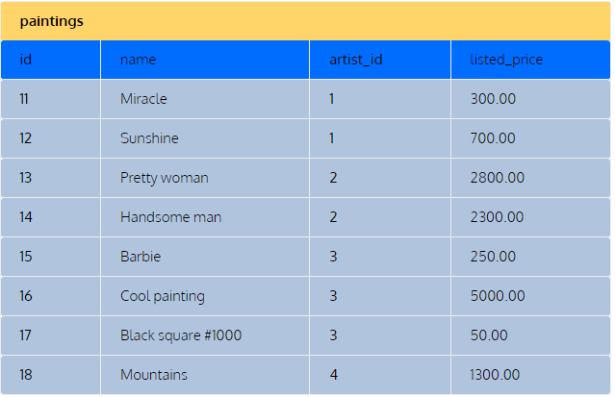

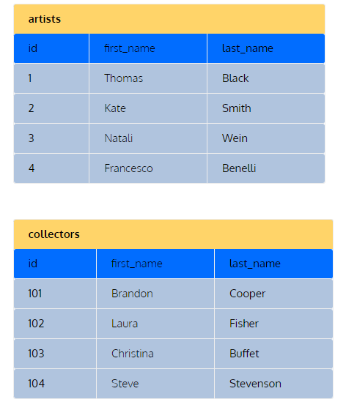

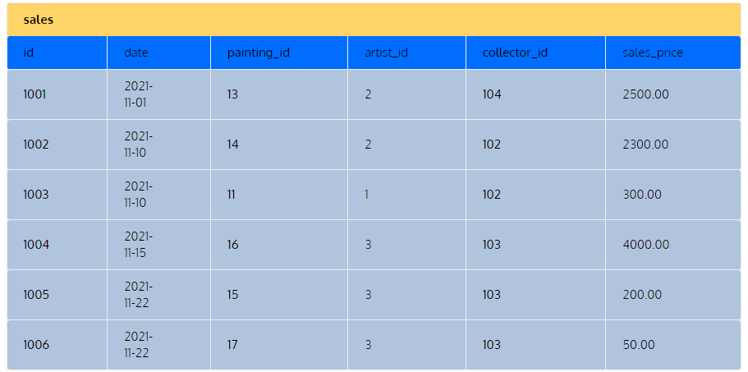

Q.1 We want to list paintings that are priced higher than the average.

SELECT name, listed_price

FROM paintings

WHERE listed_price > (

    SELECT AVG(listed_price)

    FROM paintings

);

Q.2 we want to list all collectors who purchased paintings from our gallery.

SELECT first_name, last_name

FROM collectors

WHERE id IN (

    SELECT collector_id

    FROM sales

);

OR

SELECT DISTINCT collectors.first_name, collectors.last_name

FROM collectors

JOIN sales

  ON collectors.id = sales.collector_id;

Q3 we want to see the total amount of sales for each artist who has sold at least one painting in our gallery.

SELECT

  artists.first_name,

  artists.last_name,

  artist_sales.sales

FROM artists

JOIN (

    SELECT artist_id, SUM(sales_price) AS sales

    FROM sales

    GROUP BY artist_id

  ) AS artist_sales

  ON artists.id = artist_sales.artist_id;

Q.4  we want to calculate the number of paintings purchased through our gallery.

SELECT

  first_name,

  last_name,

  (

    SELECT count(*) AS paintings

    FROM sales

    WHERE collectors.id = sales.collector_id

  )

FROM collectors;

Q.5 we want to show the first names and the last names of the artists who had zero sales with our gallery.

SELECT first_name, last_name

FROM artists

WHERE NOT EXISTS (

  SELECT *

  FROM sales

  WHERE sales.artist_id = artists.id

);